Ideation Phase

Define the Problem Statements

|  |  |
| --- | --- |
| Date | 28 September 2022 |
| Team ID | PNT2022TMID39391 |
| Project Name | Gas leakage monitoring and alerting system for industries |
| Maximum Marks | 2 Marks |

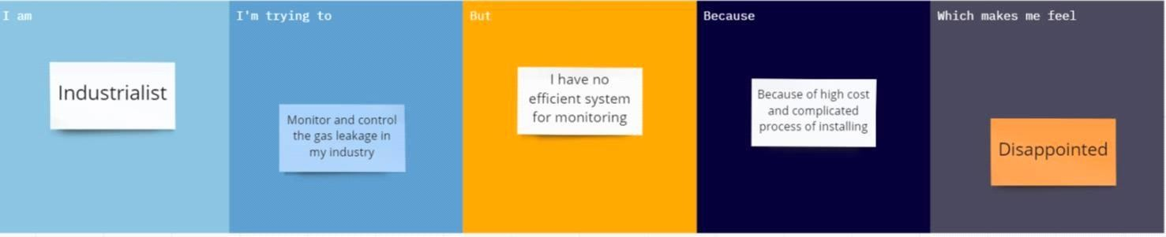

|  |  |  |  |  |  |
| --- | --- | --- | --- | --- | --- |
| **Problem Statement**  **(PS)** | **I am (Customer)** | **I am trying to** | **But** | **Because** | **Which makes**  **mefeel** |
| PS-1 | Industrialist | Monitor gas leakage in the  industry | I don’t have anysystem for monitoring | The affordable of the systemis high and the systems are sometimes  making disasters | Unsafe |